**OLAP Part 1- Investigation and Understanding**

This tutorial is in two parts, we may cover 1 or 2 sessions. The first is about understanding the OLAP cubes and pivot tables. The second tutorial is about preparing the data to support the pivot tables. Remember the ‘tools’ we are using here are an Access database and Excel for the pivot tables. Other tools are available for both tasks.

**Task 1: Open Excel and select, Insert, Pivot table,**

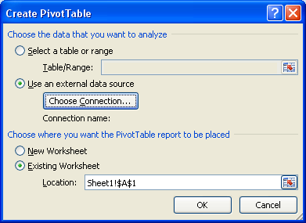

Select Use an external data source, choose connection, ‘browse for more’ and select the Orion access database and then dimArea Query.

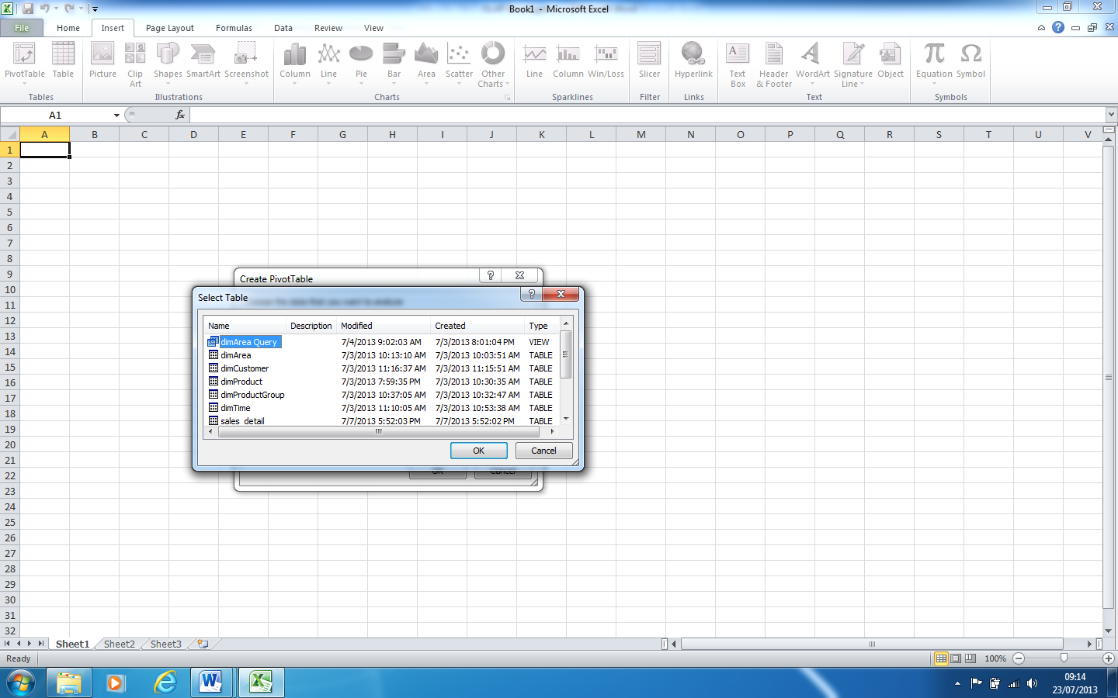

The spreadsheet will now have a skeleton pivot table in the top left of the spreadsheet and a data selection area on the right (as below).

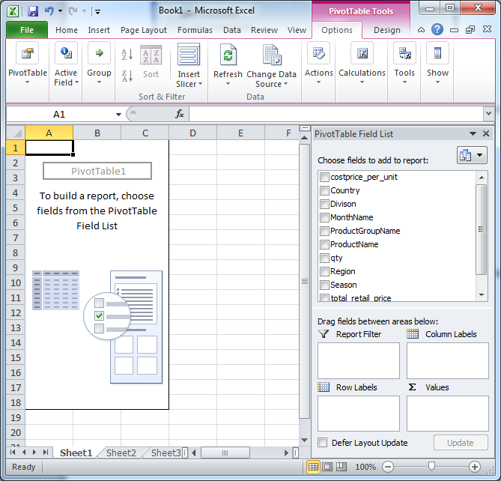

**Task 2: Explore and understand**

The 'Pivot Table Field List' (above right (top)) is the list of attributes which can be dropped into the spreadsheet, VIA the four empty white boxes underneath the field list. It is into these four boxes, that you will slowly add attributes. As you do this, those attributes and all the data associated with them, will appear in the spreadsheet to the left.

You need to perform the following actions, SLOWLY, step by step, so you can register what effect your actions have on the display of the data in the spreadsheet area. [Use the undo/do 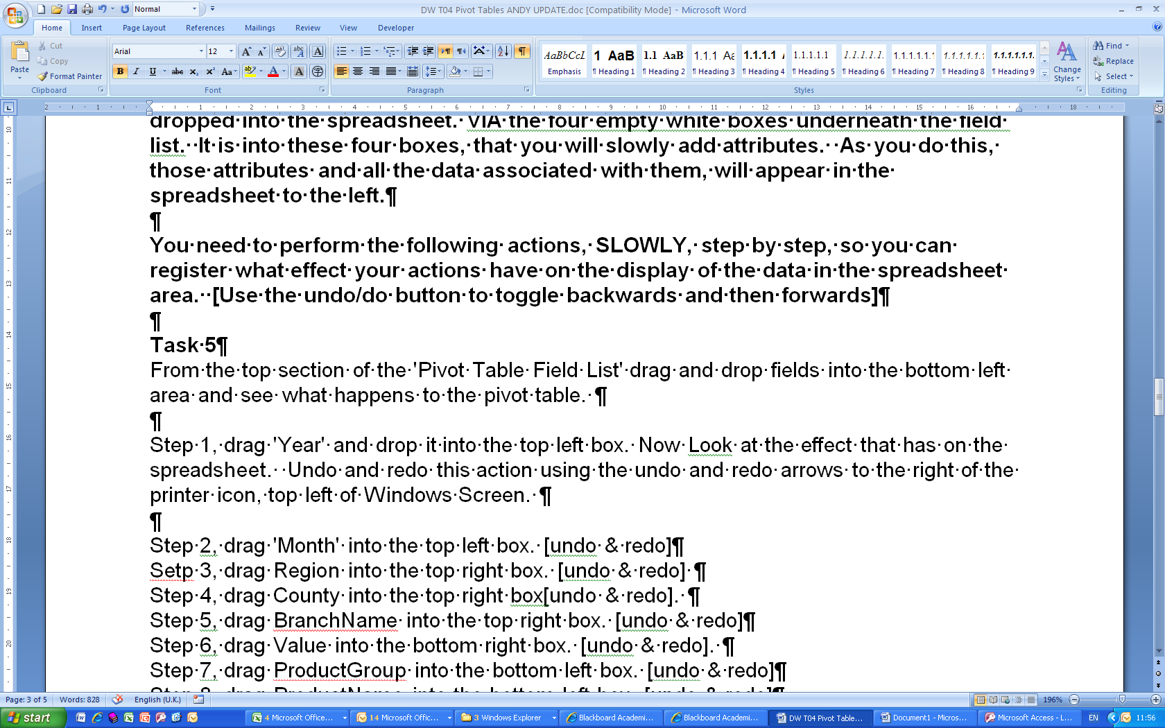 to toggle backwards and forwards a few times to embed in your understanding what effect your actions have]

Try this:

Step 1, drag 'Year' and drop it into the top left box. Now Look at the effect that has on the spreadsheet. Undo and redo  this action

Step 2, drag 'MonthName' into the top left box. [undo & redo  ]

Setp 3, drag ‘Country’ into the top right box. [undo & redo ]

Step 4, drag ‘Region’ into the top right box[undo & redo ].

Step 5, drag ‘Qty’ into the bottom right box. [undo & redo ]

Step 6, drag ‘ProductGroupName’ into the bottom left box. [undo & redo ]

Step 7, drag ‘ProductName’ into the bottom left box. [undo & redo ]

By dragging and dropping fields into boxes, explore the data. Can you use the tool to find answer to typical analytical questions?

Explore the data by repeating the exercise above in reverse order. Does it work?

**Task 3: Try for yourself:**

Use the pivot table to answer questions. Such as:

* How many sales are there per productgroup (then drill down to see sales per product group per year).
* What are the sales like ‘season’ on ‘season’? again drill down to see sales per product group per season, then drill down again to see per product.
* Can you think of some of your own? Consider the design of dimensions and measures (and aggregates).

In order to do this exercise the access database had to be prepared – which we will do next. Be aware that PivotTables/PivotCharts are just about the most simple way of exploring and visualising the data.

**Task 4: Play with the charts and the slicers**

Take one of the queries above and use the visual tools – to investigate and ‘tell a story’.

Eg In general sales are … we can see by season … however this product ….

Reading

1. ***Article Reviews***

Read and take notes on the following online articles:

<http://www.1keydata.com/datawarehousing/molap-rolap.html>

<http://www.donmeyer.com/art3.html>

<http://businessintelligence.ittoolbox.com/documents/document.asp?i=2934>

... and any others that you can find.

**OLAP Part 2– Towards a DW database**

Open in Access the Orion database.

**Task 1: Familiarisation**

You will see:

* Dimension tables
* Fact tables
* Detail tables and
* Queries.

Step 1: Open up the tables and look at the data in them. The ‘detail’ table is an unnormalised table containing all the data. Check out via ‘database tools’ and ‘relationship tools’ how the fact table and dimension tables are linked (again no surprises here).

Step 2: Open up the relationship diagram and draw the ERD for the fact and dimension tables.

How is the FACT table related to the dimension tables?

Step 3: Look at the data in the fact and dimension tables (how many rows in each table, which are PK’s and FK’s, which data is pre-calculated?)

**Eg dim_area**

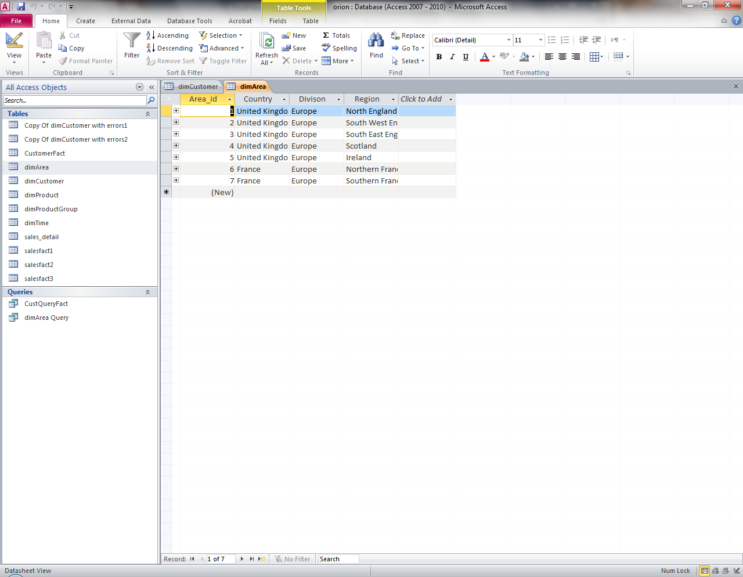

**And**

**The fact table**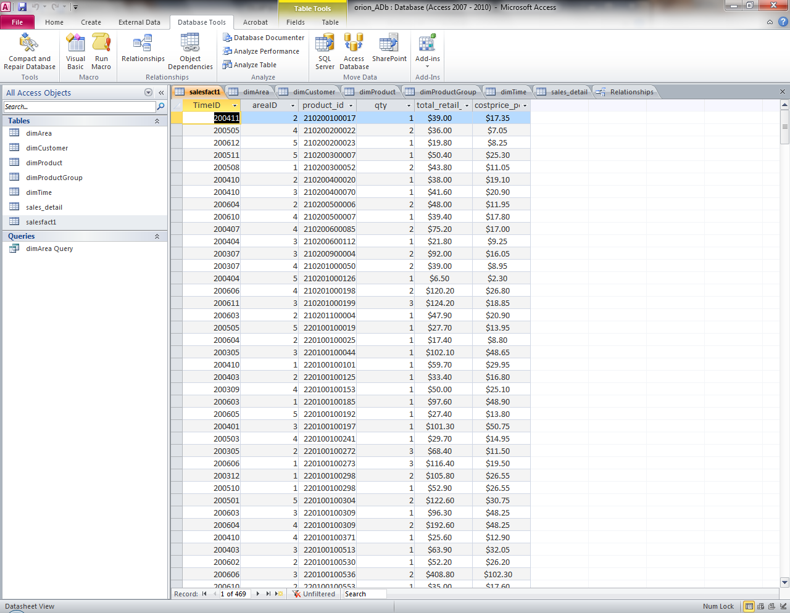

In the fact table – note which fields hold calculations? How has this calculation been worked out?

In the first row – what are does ‘total retail’ relate to? which product code?

How would you work out the total retail for south west England for all products?

Step 4: Look at the SQL and the data for the sales_detail table. Where has this data come from? Is it normalised? How is it different from the dimArea Query?

**Task 2: Go back to Excel**

Excel is just being used as a visualisation tool here. Go back and see how we ‘imported’ pre-formatted data and used Excel to produce useful visualisations.

**Task 3: Go back to orion**

Note how the Db (a star schema) looks like this:

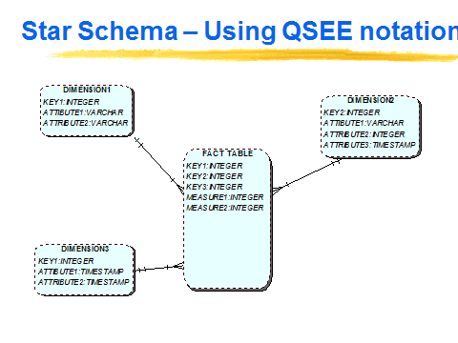

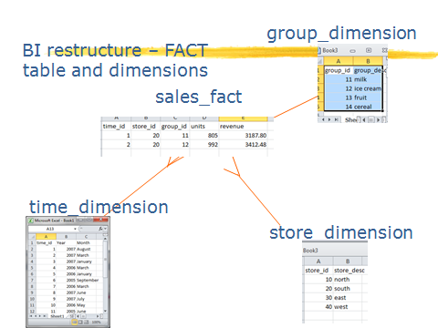

**Task 3: Your turn – Dimension and FACT tables**

You have a table dimCustomer – which has the customers and information about them. You have the Sales_detail table which holds the sales per customer.

Step 1: Identify and create a customer_fact table with suitable measures. How will you work out the values for the measures?

Step 2: Ensure the relationships are set up between PK’s and FK’s for the customer_fact and the dimCustomer.

Step 3: Create a Query Customer_Qry to support the analysis for customer and their sales.

Step 4: Open up Excel, insert a pivot table linking to Customer_Qry and test it out. Review and Reflect.

**Task 3: Your Turn – the Detail table**

Can you insert as a pivot table the sales_detail directly? Maybe you need a query in Access ‘detail_qry’ which selects all from sales_detail. How does this work, is it useful? Is it as good as/better than using a star schema model? Can you think of limitations?